ISLAMIC UNIVERSITY OF TECHNOLOGY

Organization of Islamic Cooperation

Board Bazar, Gazipur

Geometry of  
Linear Algebra

MATH 4341

Md. Mohsinul Kabir

**Problem 1**

Observations:

* Top row decreases and bottom row increases
* Change in top row Change in bottom row
* Sum of columns (Markov Matrices)

**Problem 2**

The Schwarz inequality states

The triangular inequality states

Both inequalities are proven.

We know,

**Problem 3**

Vector is perpendicular to since

There is only one other possibility for , i.e. .

**Problem 4**

a) and are linearly independent, so all their combinations will be a plane in .

b) and are linearly independent, so all their linear combinations will be a plane in .

c) , and are linearly independent, so all their linear combinations will be a plane in .

**Problem 5**

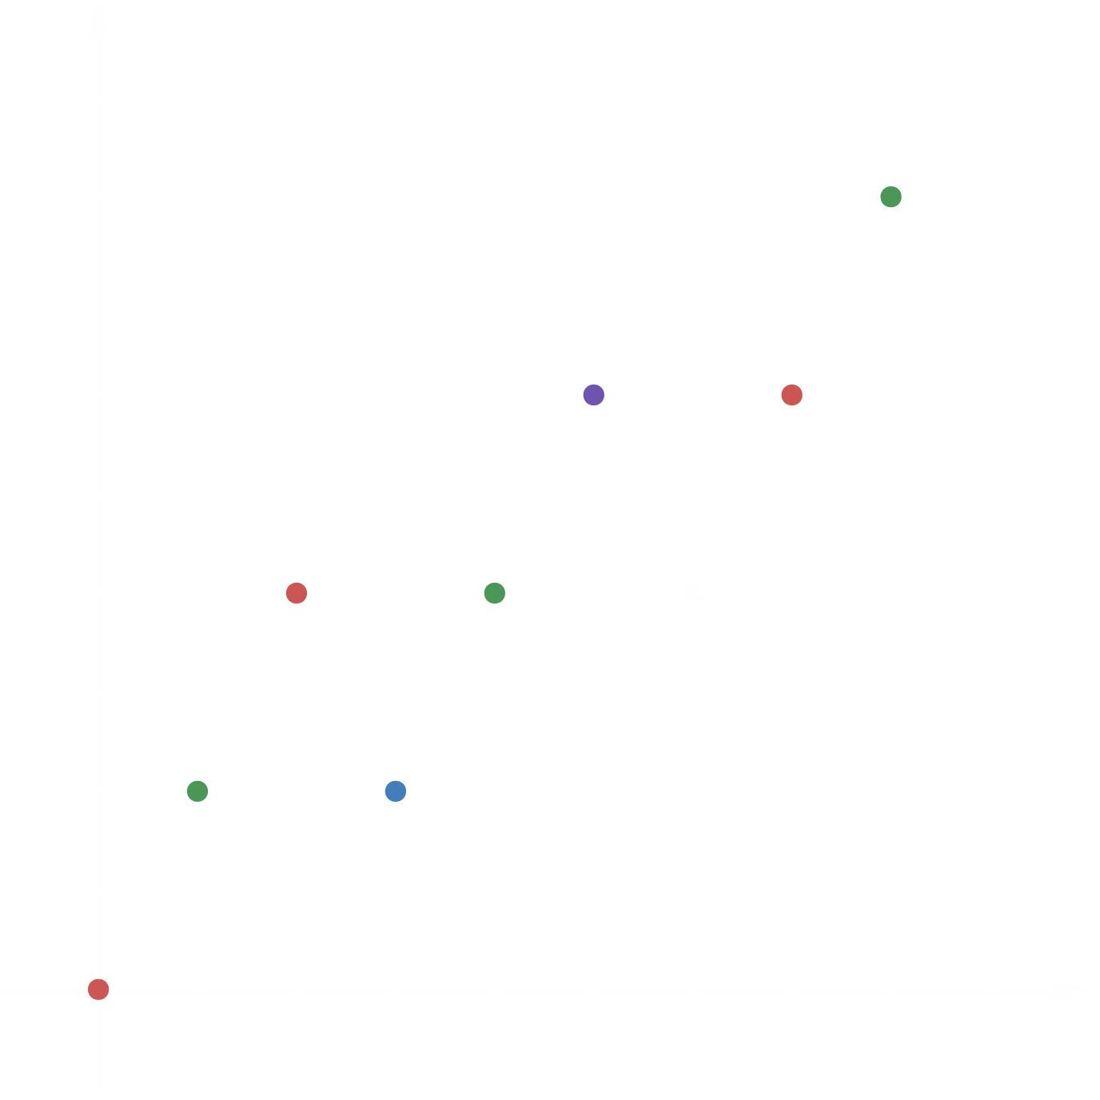

**Problem 6**

Combination 1:

Combination 2:

Any three vectors may not always produce . They will fail to do so if all three are on lines that do not contain .

**Problem 7**

- ()

- ()

- ()

From equation (),

From equation (),

From equation (),

**Problem 8**

The vectors , and would form only a line.

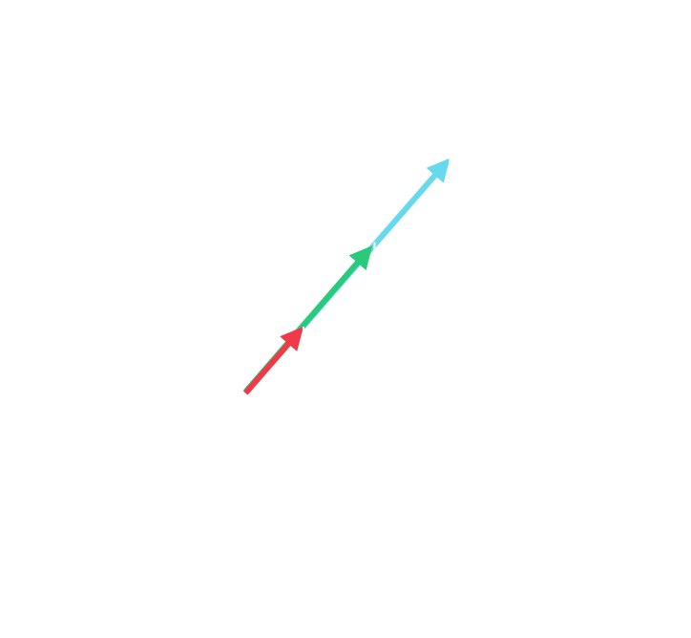

The vectors , and would form a plane.

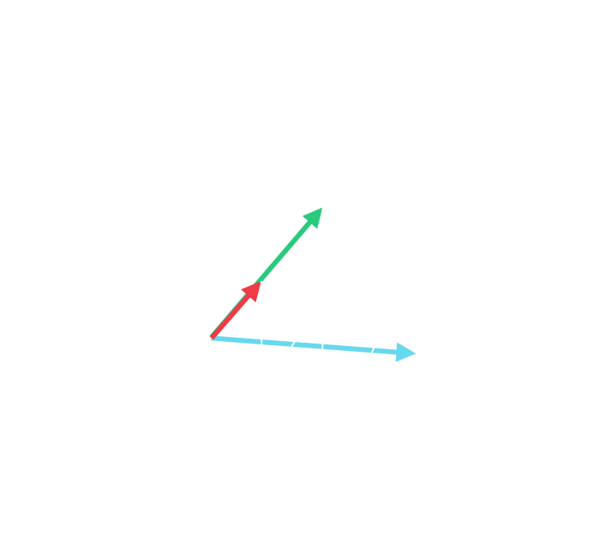

**Problem 9**

The other four corners are , , and .

The centre of the cube is .

The centre points of the faces are:

, , , , and .